Since 2020, the pandemic has become a mainstream topic in the world due to the impact of COVID-19. The whole world has been inevitably affected and begun to change by the pandemic. This visualization report will take the pandemic as the starting point, starting from the analysis of Hong Kong's vaccination situation, then relate to the unemployment rate in Hong Kong, and finally, based on the perspective of patent publication, analyze the impact of the pandemic on global patent publication.

1. **Analysis of the two types of vaccination in Hong Kong (as of 14-10-2022)**

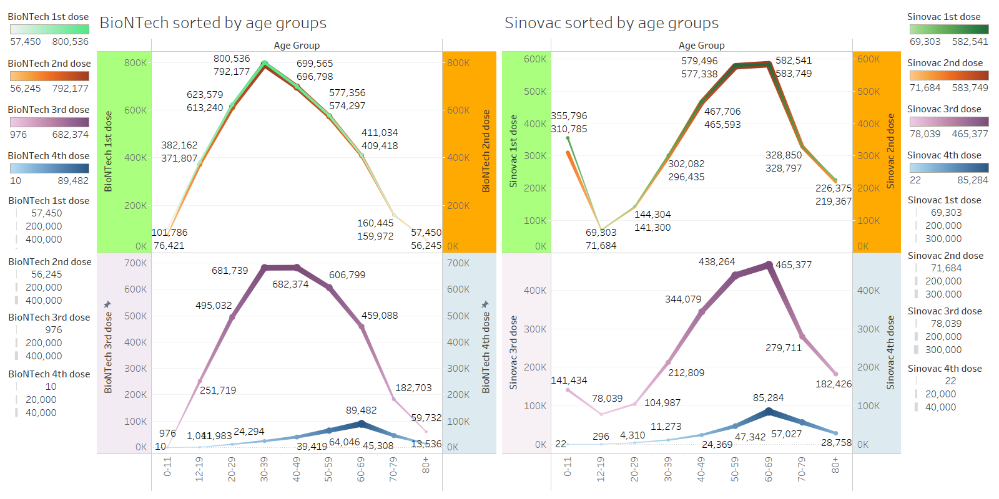

**Figure 1**

**1.1 Analysis of the BioNTech vaccination**

The left half of Figure1 shows the vaccination status of the BioNTech vaccines. It can be seen from the figure that there is only a slight difference between the first two vaccination in each age group. The figure starts from the 0-11 age group. As the age increases, the number of vaccinations gradually grows. The peak appears in the 30-39 age group, with the most significant number of vaccinations in the first two doses, 800,536 and 792,177, respectively. After this age group, the number of vaccinations began to decline gradually.

The situation of the third vaccination dose is similar to that of the first two doses. Interestingly, the number of people in the 40-49 age group who received the third shot exceeded the 30-39 age group, reaching 682,374, becoming the largest age group. However, the gap is not that large, and the number of vaccinations in the 30-39 age group is still at a high level, reaching 681,374.

However, the fourth vaccination dose is in stark contrast to the first three doses. The number of people in all age groups who received the fourth dose has dropped significantly. In addition, although the overall trend is similar to that of the first three doses—rising first and then falling, the regulation line shape is right-skewed, with a peak at 60-69 (89,482), while the number of people inoculated in the first three doses The 30-39 age group, which has been at the top, only received a fourth dose of 24,294.

From the figure, it can be roughly calculated that the number of people who received the first two shots in each age group before the age of 39 was 100,000 higher than that of those who received the third shot; After the age of 49, the situation is opposite, the number of people who received the third dose is more than the first two doses.

**1.2 Analysis of the Sinovac vaccination**

The right half of Figure 1 is the vaccination situation of the Sinovac vaccine. The figure of the first three injections generally presents an S-shaped trend, and the least number of vaccinations is in the 12-19 age group, which are 69,303, 71,684, and 78,039, respectively. After that, the number gradually increased with age. The peak group is the 60-69 age group, which account for 582,541, 583,749, and 465,377, respectively, and then gradually decreases with the increase of age groups.

According to the fourth dose, the age group with the most vaccinations is the same as the first three doses in the 60-69 age group, reaching 85,284. In addition, unlike BioNTech, the number of people vaccinated with the first two doses of Sinovac in all age groups is higher than that of the third dose.

**1.3 overview**

From the integrated dashboard, there are some meaningful findings:

1) Regarding the vaccination status of the first three doses of vaccines, the distribution patterns of the two types of vaccines are the same. Among them, BioNTech presents the shape of a bell with a normal distribution. At the same time, Sinovac also had normal distribution except for the particular case of the 0-11 age group. Still, it is a right-skewed distribution biased toward the older age group.

2) Inoculation in the third dose will be less than in the first two doses. Besides, the number of people in Hong Kong receiving the fourth dose is generally very low. This may be because the first three doses are mandatory to some extent, but the fourth dose does not seem to be the “must-do” for people. Therefore, people's willingness to actively inject the fourth dose is generally not high.

3) From the perspective of "preference," the three age groups, 0-11, 50-59, and 60-69, seem to be more willing to receive the Sinovac vaccine, while the two age groups, 30-39 and 40-49 prefer to get the BioNTech vaccine. The situation is probably because each of these two types of vaccines may have a more suitable vaccination population, such as the Sinovac vaccine, which may be more appropriate for the above three age groups and less prone to adverse reactions.

4) The peak vaccinations of the fourth dose of the two types of vaccines are in the 60-69 age group. On the one hand, it may be because the elderly have relatively weak autoimmunity, so they are encouraged to get the fourth dose of vaccine to reduce the risk of infection. On the other hand, compared with young people, the elderly are more willing to get the fourth dose. The older people think that one more shot of the vaccine will give them more protection and safety, while young people choose to believe in their immunity.

**2. Analysis of Hong Kong's unemployment rate**

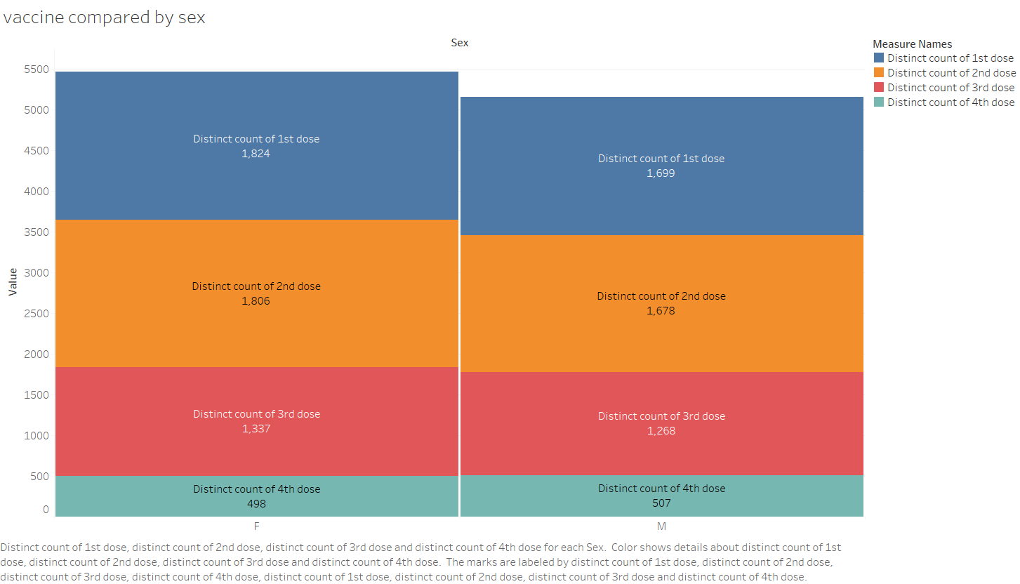

**Figure 2.1**

This part will first take the male and female vaccination status into account. According to the figure2.1, except for the fourth dose, the number of females vaccinated in the first three doses is higher than that of males. Part of the group is how due to the gender gap in Hong Kong's population – 3,382,300 and 4,030,800 male and female, respectively[(Link).](https://www.censtatd.gov.hk/tc/EIndexbySubject.html?pcode=B1130303&scode=180) On the other hand, from a health viewpoint, many males are unsuitable for vaccination because they are generally more likely to suffer from primary diseases than females. Regarding this background, the issue of unemployment rates for men and women is analyzed.

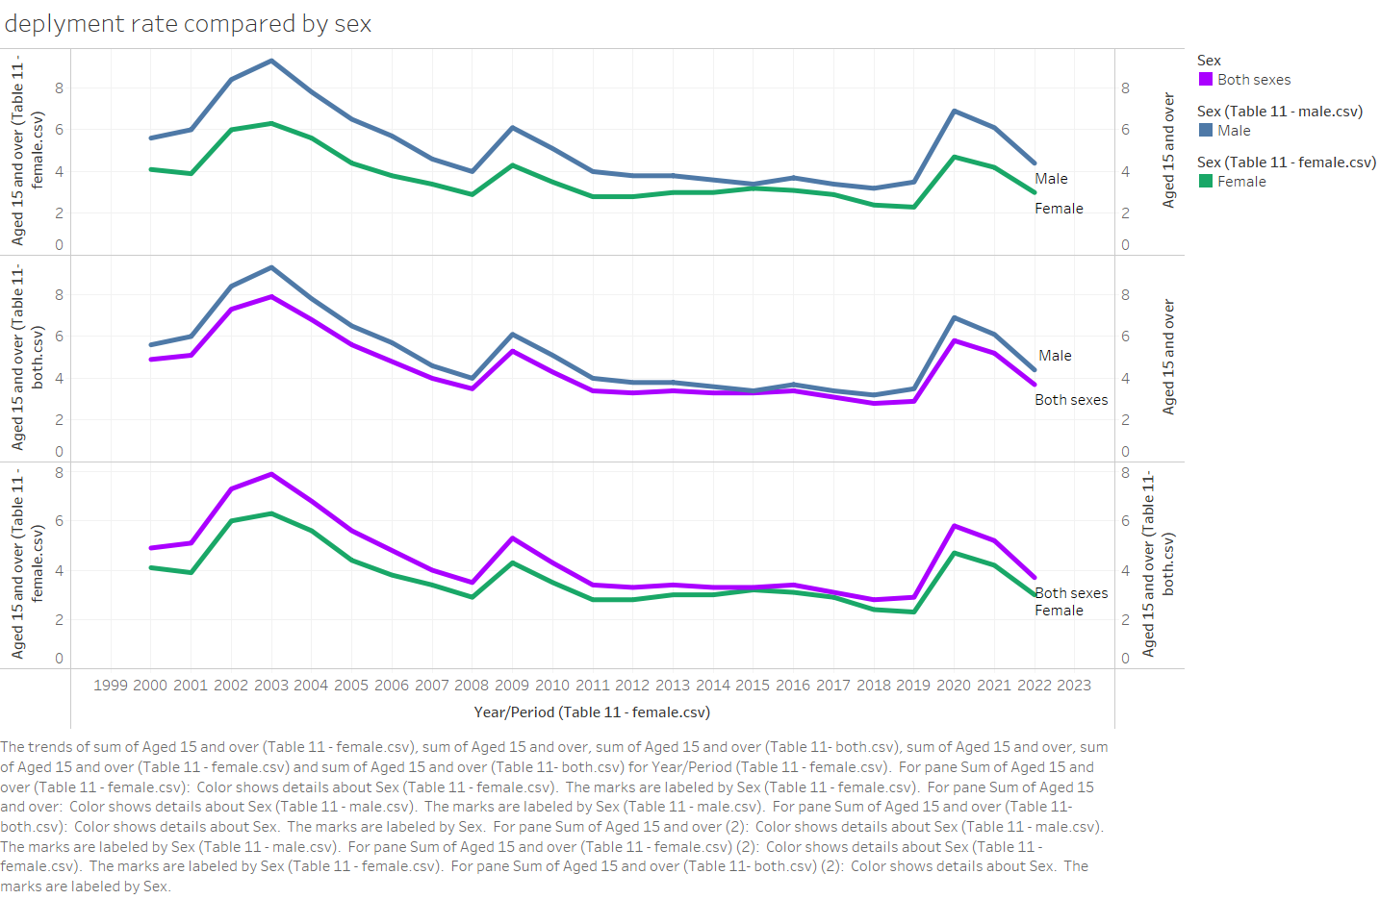

**Figure 2.2**

The figure2.2 shows that the unemployment rate presented by the three indicators (Male, Female, and Both) is consistent. Since the beginning of the 21st century, Hong Kong has experienced three relatively large periods of unemployment in 2003, 2009, and 2020. Among them, the increase in unemployment in 2003 is likely to be affected by SARS; The reason for the rise in unemployment in 2009 should be the impact of the 2008 global financial crisis, and it is to be expected that Hong Kong, as the financial center of Asia, will undoubtedly be affected. Finally, due to the impact of the epidemic in 2020, many industries were forced to stop working, which naturally became the main reason for the increase in unemployment. But Hong Kong's overall unemployment rate has declined over the past 20 years.

Throughout the period, the unemployment rate for men has been higher than women. After the second outbreak of unemployment in 2009, the gap between men's and women's unemployment slowly narrowed, and at one point, it also approached equality. However, after the outbreak of the epidemic in 2020, although the unemployment rate has increased, the impact on men is more significant, and the gap between the two has widened again. According to the analysis in Figure 2.1, this may be partly because men cannot meet the requirements of some jobs. After all, fewer people have been vaccinated than women, so they cannot find work.

The overall unemployment rate for girls has been consistently lower than the overall unemployment rate, reflecting that girls may perform better than men in the job market.

**3. Analysis of world patent publications from 2017 to 2021**

**3.1 top ten countries and regions overview**

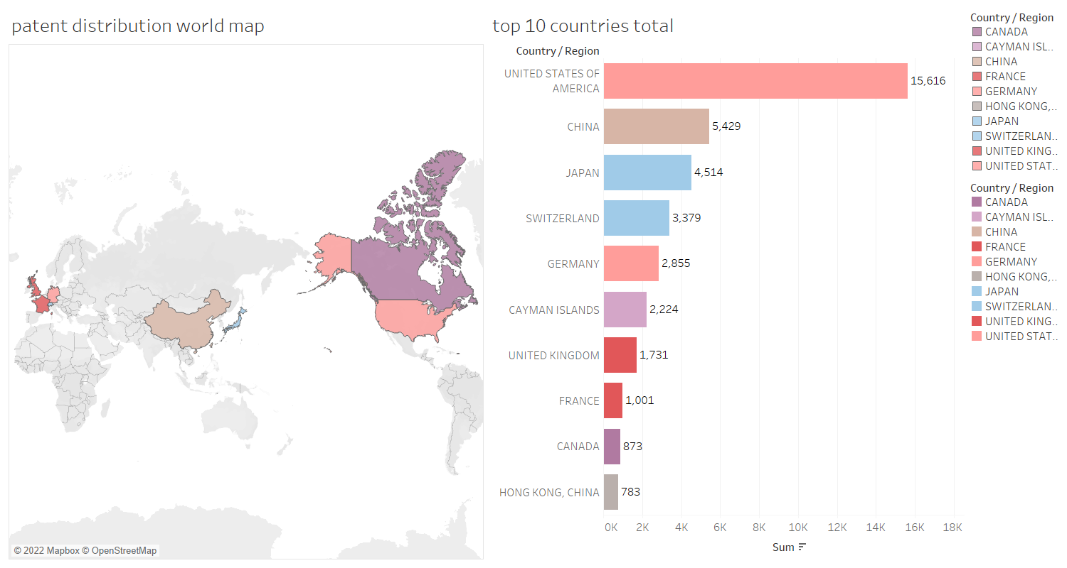

**Figure 3.1**

As seen in the figure3.1, the top ten patent publications in the world during these five years were concentrated in Europe, North America, and Asia. Specifically, the United States ranked first, with a total of 15,616, about three times the number of China (ranked second), followed by Japan, Switzerland, Germany, the British Kaman Islands, the United Kingdom, France, and Canada. It is worth mentioning that Hong Kong also ranked in the top ten, with a cumulative number of patent applications reaching 783, indicating that Hong Kong has been a world leader in all aspects.

**3.2 analysis of top 10 countries sorted by years**

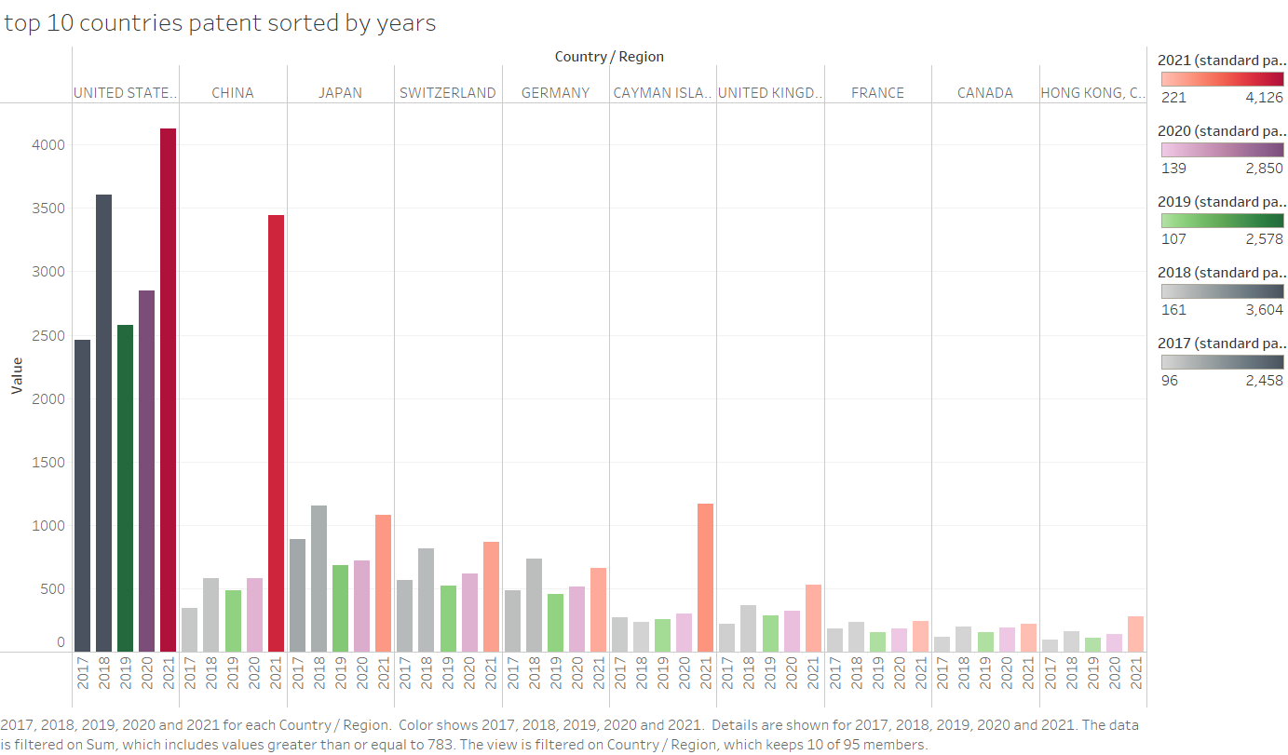

**graph 3.2**

From the analysis of the annual application volume of the top ten countries and regions in Figure 3.2, the number of patent applications in the top 10 in 2019 has decreased. The reason may be that they are starting to focus more on invention patents that generate value, more on quality than quantity, rather than filing for the sake of filing. For example, in 2019, some relevant parts of China announced that they were transforming from a major importer of intellectual property to a significant country of intellectual property creation.

In addition, unexpectedly, when many people thought that the publication of patents would continue to decline due to the epidemic's impact in 2020, the number of patent publications began to rise after 2020, and the number of increases in 2021 was the highest. For example, Chinese mainland, the number of applications filed in 2021 was at least five times higher than in 2020.